**Computational Neuroscience**

Aya Elnaser Salah-4221028

**Build an RNN and the text contains 4 words. The target is predicting the 4th word**

**How I did my code:**

1. **Initialize the RNN:**

Weight and Bias

Start with hidden state”0”

1. **Forward pass:**

-one-hot vector

” is a way to represent words as numbers so that a computer can process them”

-Update the hidden state using tanh

-Compute output probabilities for the next word

1. **Training:**

-Cross entropy loss for the predicted word

-Update weights using gradient descent

-Only predict the 4th word given the first 3 words

1. **Data Preparation:**

-Split text into sequences of 3 words → predict the 4th

-(word_to_idx)

1. **Prediction**:

-Feed a 3-word sequence → get the most probable next word

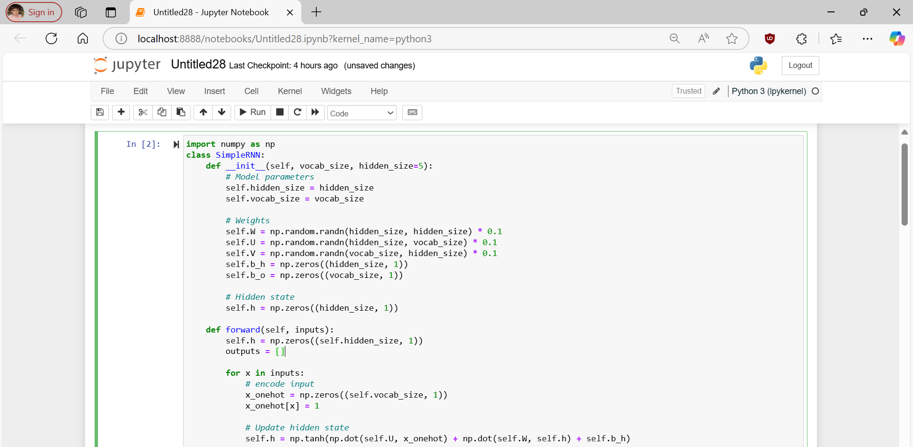The word I used: I love neuroscience

